How to implement “Image mapping plugin” into TinyMCE editor
In this instruction we will work from working path (WP) = "/var/opt/intershop/eserver1/share/system/cartridges/sld_enterprise_app/release/static/default/".
- From archive, copy folder “imagemap” and insert it into: WP + /tinymce/jscripts/tiny_mce/plugins/ ;
- In file : WP + /htmleditor/(AdvancedEditor.js or BasicEditor.js). See screenshot below:

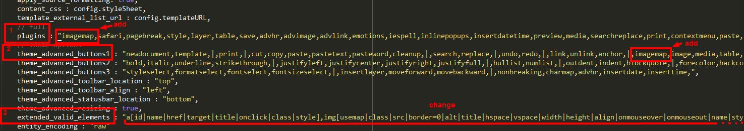
- in 1 and 2 selections, just add “imagemap” string into appropriate fields;
- in 3 selection change string to:
"a[id|name|href|target|title|onclick|class|style],img[usemap|class|src|border=0|alt|title|hspace|vspace|width|height|align|onmouseover|onmouseout|name|style],hr[class|width|size|noshade],font[face|size|color|style],span[class|align|style],map[name|id],area[shape|coords|href|target|title|alt]" .

- In folder: WP + /tinymce/jscripts/tiny_mce/themes/advanced/img/
add file - “imagemap.gif” from archive;
- In file: WP + /tinymce/jscripts/tiny_mce/themes/advanced/skins/intershop/ui.css
add string : “.intershopSkin .mce_imagemap{background:url(../../img/imagemap.gif) center center no-repeat;}” ;
- In folder : WP + /tinymce/jscripts/tiny_mce/plugins/contextmenu/
replace files “editor_plugin.js” and “editor_plugin_src.js” from archive’s folder “Custom_contextmenu”.

